**Artificial Intelligence and Machine Learning**

**LAB 5**

**Name: PUNEETH L**

**USN: 1BM24MC069**

**5. For a dataset, implement K-means clustering algorithm and visualize the clusters.**

**Program:**

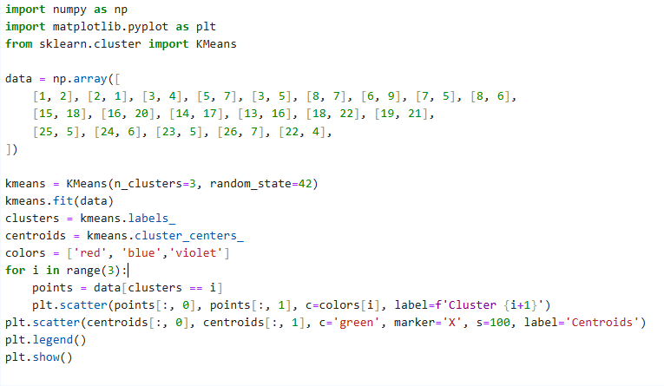

**OUPUT:**

